ASES Fourth Grade Supply List
2019-2020
- iPad-4th generation or newer. Any size, no cell service needed (Large is easier to see)
- Apps downloaded-see list
- iPad protective case
- Wireless Bluetooth keyboard (Like the one below. We had a lot of problems with the keyboard cases. Any brand will be fine as long as it is not attached to the case.
Arteck HB030B Universal Slim Portable Wireless Bluetooth 3.0 7-Colors Backlit Keyboard with Built in Rechargeable Battery, Black | 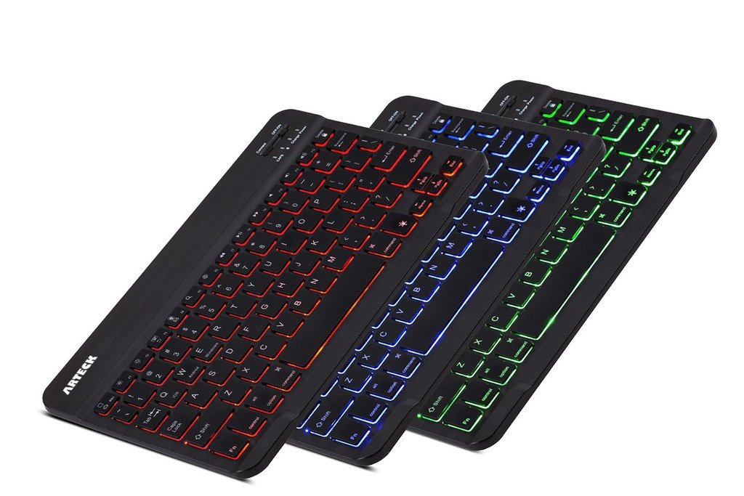

- Small Headphones
- 3 Spiral Notebooks with at least 120 pages
- CRAYOLA Erasable Colored pencils (12)
- CRAYOLA Fine Tip magic markers (12)
- CRAYOLA Crayons (24)
- #2 mechanical pencils (0.7mm)
- 3 Inch and a Half 3 Ringed Binder
- 1-Two Inch 2 Ringed Binder
- Tacky Glue
- Scissors
- 12 inch ruler ( The rulers from Dollar Tree are not always to scale)
- 3 packages of Wide Ruled notebook paper (College ruled paper is not acceptable)
Art - Large shirt to go over school clothing and a sketchbook
Locker- A locker shelf is helpful in keeping the lockers organized! (optional)

